**SINGLETON DESIGN PATTERN**

Logger.java

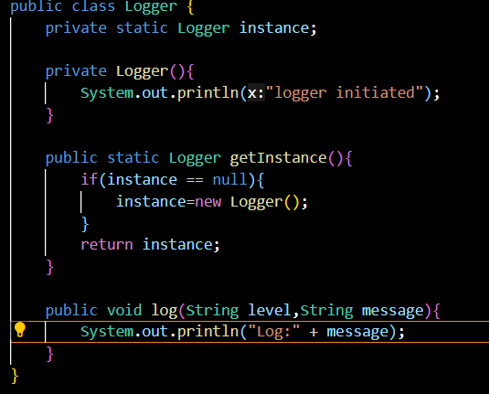

main.java

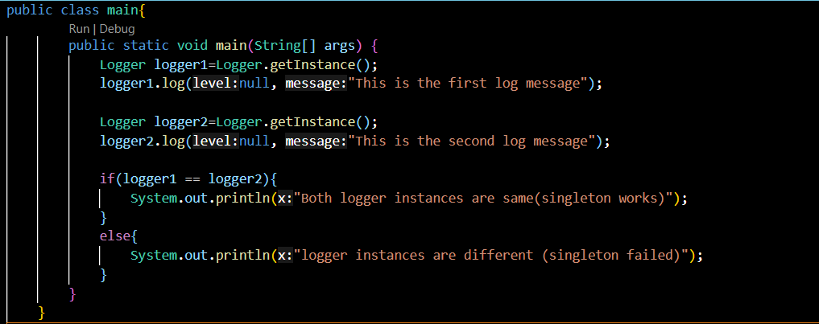

**OUTPUT**

